Clickable Map with Parking sensor data and bar charts

In this demo you will learn how to recreate this clickable map that selects parking bays according to how close the bays are to the point selected on the map. The demo also presents you with two bar charts showing the hourly availability and the daily availability. The results are aggregated over the last 28 days. Click the picture below or here to access the demo.
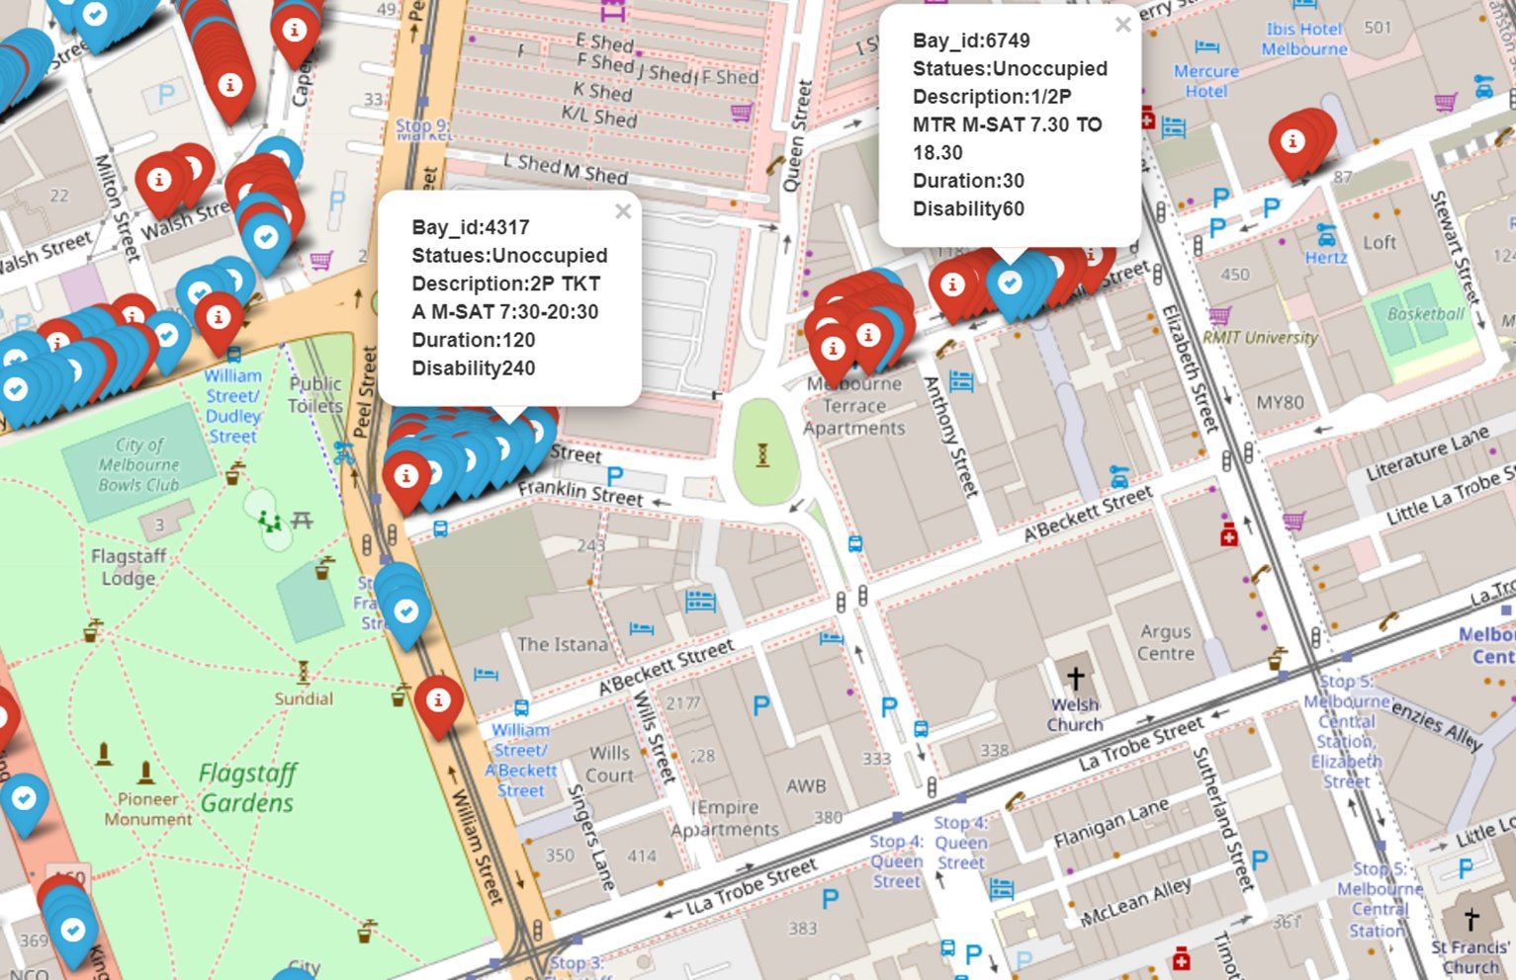

LEARN HOW TO DO THIS ↑

START HERE

For educational python notebooks go to bottom
In this demo you will learn how to recreate this clickable map that selects parking bays according to how close the bays are to the point selected on the map. The demo also presents you with two bar charts showing the hourly availability and the daily availability. The results are aggregated over the last 28 days. Click the picture below or here to access the demo.

CODE SNIPPET
RESULT

In this demo you will learn how to recreate this clickable map that selects parking bays according to how close the bays are to the point selected on the map. The demo also presents you with two bar charts showing the hourly availability and the daily availability. The results are aggregated over the last 28 days. Click the picture below or here to access the demo.

CODE SNIPPET
RESULT

In this demo you will learn how to recreate this clickable map that selects parking bays according to how close the bays are to the point selected on the map. The demo also presents you with two bar charts showing the hourly availability and the daily availability. The results are aggregated over the last 28 days. Click the picture below or here to access the demo.

CODE SNIP

Credentials and ETL – Extract, transform, load. How to get the data over time and how to access the API on the backend so you can get all the available data when you want it.

Clickable map – How to make a map clickable?

Geo-algorithms – So you’ve selected a point on a map how to select every parking bay within a radius

Bar charts – How to create bar charts from live data.

Architecture – How it all pieces together.

